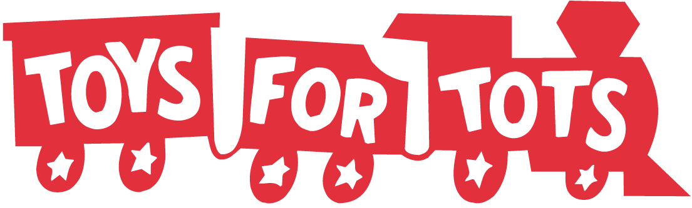
INDIVIDUAL FAMILIES REQUEST FOR TOYS 2024

Contact Information
Full Name
Address | Street  City State Zip
Primary Contact Name |  |  |  |  |  |  |  | Cell
Primary Contact Email
Alternate Contact Name |  |  |  |  |  |  |  | Cell

Specify (with an X) the government assistance you are currently receiving

Allkids Link Lunch Programs- Free Reduced WIC
Others

If you are not receiving government assistance, briefly tell us why you feel you qualify for assistance from Toys for Tots
Toy requests are accepted for either your own children or those that you have legal guardianship for. Proof of children’s status within your family will be required. Tell us below the children’s name(s) by gender and (mark X) under age group of each child.
Boys Name(s) |  | 0-2 | 3-5 | 6-9 | 10-12 |  | Girls Name(s) |  | 0-2 | 3-5 | 6-9 | 10-12

The Will County Toys for Tots program works with non-profit organizations that meet our requirements and agree to directly distribute toys to families. The information you provided above will be used to assist in getting you registered with an organization that we provide services to.

- At the time of pick up, you can be asked to bring:
  - Picture ID (as proof of identity).
  - Birth certificate or immunization records for EACH child.
  - Utility bill, paystub or piece of mail that shows your current address (as proof of residency in Will County).
  - Government assistance paperwork per your listing above (as proof of eligibility).
- Once your request is approved, you will be contacted by either Toys for Tots Coordinator or an organization that we found to assist you. The purpose is to coordinate a date, time and location for toy pickup.
- We can only guarantee ONE toy per child and no toy request will be filled if received after the date that your agency deems late.
- Toys for Tots can only provide you with TOYS. We do not offer assistance with clothing, shoes, food, etc. We recommend you contact a pantry, church or the organization you are referred to as to where you can get help with those items.
- Toys should be requested from only ONE and not multiple Toys for Tots distribution centers.
- Understand that orders can only be filled with toy inventory available at the time the order is approved.
- You must further agree that toys donated by Toys for Tots will not be auctioned, sold, turned over for monetary donations or taken out of state for distribution.

With this signature |  | Dated / / 2024
I agree to the above terms and understand any violation of this agreement will disqualify me from future donations.

